AI PHASE 4

**DEVELOPMENT of AI-driven exploration and prediction of company registration trends with the Registrar of Companies (ROC)**

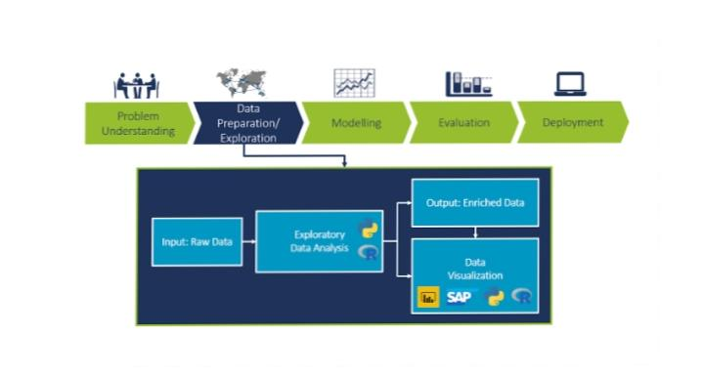**1)PERFORMING EXPLORATORY DATA ANALYSIS:**

Exploratory Data Analysis (EDA) is a crucial step in understanding and preparing data for AI-driven exploration and prediction. Here’s a high-level approach for analyzing company registration trends with the Registrar of Companies (ROC):

1. **Data Collection**: Obtain historical data on company registrations from the ROC. This might include details like registration date, company type, industry, location, and more.
2. **Data Cleaning**: Clean the dataset to handle missing values, outliers, and inconsistencies. This ensures that the data is in a usable form for analysis.
3. **Data Visualization**: Create various visualizations to understand the data. Use tools like histograms, scatter plots, and bar charts to explore the distribution of company registrations over time and across different categories.
4. **Descriptive Statistics**: Calculate basic statistics such as mean, median, and standard deviation to gain insights into the data’s central tendencies and variations.
5. **Time Series Analysis**: Since you’re interested in trends over time, perform time series analysis to identify any seasonality, trends, and anomalies in the company registration data.
6. **Correlation Analysis**: Examine correlations between different variables to understand if there are any relationships that might influence company registrations.
7. **Geospatial Analysis**: If your data includes location information, use geospatial tools to visualize regional variations in company registrations.
8. **Feature Engineering**: Create new features or transform existing ones to better represent the data for AI modeling. For example, you could create lag features for time series analysis.
9. **Machine Learning Models**: Train predictive models, such as regression or time series forecasting models, using your prepared data. These models can help you predict future company registration trends.
10. **Evaluation and Validation**: Assess the performance of your predictive models using appropriate metrics and cross-validation techniques. Ensure that the model’s predictions align with your exploratory findings.
11. **Interpretability**: For AI-driven exploration, it’s essential to make the models interpretable. Understand how the model makes predictions and what features influence those predictions.
12. **Feedback Loop**: Continuously update and refine your models as new data becomes available from the ROC. Monitor your predictions and validate them against real-world data to improve accuracy.
13. **Visualization and Reporting**: Present your findings and predictions using data visualization tools and clear reports to communicate insights effectively to stakeholders.

Remember that EDA is an iterative process, and it may involve going back and forth between these steps to refine your analysis and predictions. Additionally, the specific tools and techniques you use will depend on the nature and volume of your data.

2)**FEATURE ENGINEERING:**



Feature engineering is a critical step in the process of exploring and predicting company registration trends with the Registrar of Companies (ROC) data. Here are some feature engineering ideas to help improve your AI-driven analysis and predictions:

1. **Date-Based Features**:

- Extract year, month, and quarter from the registration date.

- Calculate the age of companies (the time since registration).

- Identify public holidays or special events that might affect registration trends.

2. **Lagged Features**:

- Create lag features to capture historical trends, such as the number of registrations in the previous month or quarter.

- Calculate rolling statistics (e.g., moving averages) for various time periods.

3. **Categorical Features**:

- One-hot encode categorical variables like company type, industry, and location.

- Create new features that capture combinations of categories, such as “Tech companies in New York.”

4. **Geospatial Features**:

- If location data is available, create features related to the distance from key business districts, population density, or regional economic indicators.

5. **Economic Indicators**:

- Include economic indicators like GDP growth, unemployment rate, or inflation rate as features, as these can influence business registration trends.

6. **Seasonal Features**:

- Encode seasonal information, like the quarter of the year, to capture any recurring patterns.

7. **Trend Features**:

- Calculate the trend of company registrations over time using regression analysis or other mathematical techniques.

8. **Time since Last Registration**:

- Create a feature that represents the time elapsed since the last registration in the same category or region.

9. **Competitive Landscape**:

- Incorporate data on the number of existing companies in a particular industry or region, which may impact new registrations.

10. **Social Media and News Data**:

- If available, gather sentiment analysis from social media or news sources to gauge the public perception of business prospects, which can influence registration trends.

11. **Legal and Regulatory Changes**:

- Encode changes in regulations or laws that affect the ease of registration or business conditions.

12. **External Events**:

- Incorporate data on significant external events (e.g., economic crises, pandemics) that might have impacted registration trends.

13. **Customer Reviews and Ratings**:

- If applicable, include customer reviews and ratings of businesses, which could reflect the health of the industry.

14. **Web Traffic and Online Activity**:

- If relevant, use web traffic or online search data to understand interest and demand for specific industries.

15. **Composite Indices**:

- Create composite indices or scores that combine multiple features to represent overall economic conditions or business environment.

**3)PREDICTIVE MODELING:**

Predictive modeling is a crucial component of AI-driven exploration and prediction of company registration trends with data from the Registrar of Companies (ROC). Here’s a step-by-step guide on how to approach predictive modeling for this task:

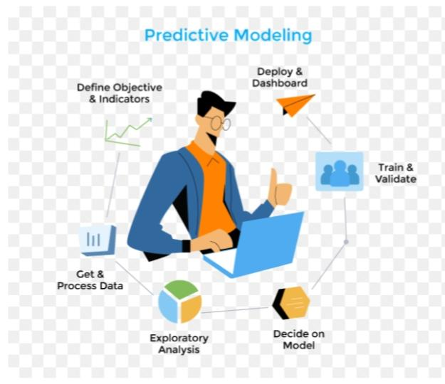1. **Data Preparation**:

- Ensure your dataset is clean, well-structured, and contains the engineered features as discussed in the previous response.

- Split the data into training, validation, and test sets.

2. **Select Appropriate Model**:

- Choose a predictive model that suits your problem. Time series forecasting models like ARIMA, SARIMA, or machine learning models like regression, decision trees, or neural networks are common choices.

3. **Baseline Model**:

- Start with a simple baseline model to establish a performance benchmark. For example, you could use a basic linear regression model to predict trends.

4. **Time Series Models**:

- If your data exhibits time-dependent patterns, consider time series models. Fit models like ARIMA or SARIMA to capture seasonality, trends, and autocorrelation in the registration data.

5. **Machine Learning Models**:

- Train machine learning models like Random Forest, Gradient Boosting, or LSTM neural networks to predict registration trends. Experiment with different algorithms to find the best fit.

6. **Hyperparameter Tuning**:

- Optimize the hyperparameters of your chosen model(s) using techniques like grid search or random search to improve predictive accuracy.

7. **Evaluation Metrics**:

- Select appropriate evaluation metrics for your model, such as Mean Absolute Error (MAE), Mean Squared Error (MSE), or Root Mean Squared Error (RMSE) for regression problems.

8. **Cross-Validation**:

- Use cross-validation techniques to ensure that your model generalizes well. Time series data may require specialized cross-validation methods like Time Series Cross-Validation.

9. **Feature Importance**:

- Assess feature importance to understand which variables have the most impact on your predictions. This can guide feature selection and refinement.

10. **Ensemble Models**:

- Experiment with ensemble methods like Random Forest or stacking to combine the strengths of multiple models.

11. **Regularization**:

- Apply regularization techniques to prevent overfitting, especially for complex models like neural networks.

12. **Model Interpretability**:

- If interpretability is essential, consider using interpretable models like linear regression or decision trees.

13. **Rolling Forecast Origin**:

- For time series data, implement a rolling forecast origin to update your model and predictions over time, taking into account new data as it becomes available.

14. **Backtesting and Validation**:

- Continuously validate your model against actual registration data to assess its performance and recalibrate as needed.

15. **Deployment**:

- Once you’re satisfied with your predictive model’s performance, deploy it in a production environment where it can make real-time predictions or forecasts.

16. **Monitoring and Feedback**:

- Continuously monitor the model’s performance and update it as new data becomes available or as the business environment changes.

17. **Reporting**:

- Communicate your predictions and their implications to stakeholders through clear reports and data visualization.

Remember that predictive modeling is an iterative process, and models can be refined and improved as you gather more data and gain insights into company registration trends with the ROC.